Title

**First Author1, Second Author2 et Third Author2**

1 : Department, Laboratory

Adress, F- code, City

e-mail : first@yyy.fr and third@yyy.fr

2 : Department, Laboratory

Adress, F- code, City

e-mail : second@yyy.fr

Abstract

Instructions for the EWGAE paper

Length: **2 to 8 pages**

**margins are fixed to 2 cm.**

**Please write here your abstract in English (200 words max.)**

**Keywords :** please give between 3 and 5 keywords

1. Introduction – Level 1 heading
   1. **Continuation of instructions, Level 2 heading**

The idea is to make all the articles look as uniform as possible.

Body text : 12 point Times New Roman, justified.

Title : centred in Times New Roman 14 pt bold, followed by a blank line 18 pt Times New Roman.

Authors’ names : centred in Times New Roman 10 point bold separated by a comma, ownership

identified by a superscript number.

Authors’ e-mail addresses : centred in Times New Roman 8 pt. A 10 point Times New Roman blank

line will be left between each address. After the last address, there will be a blank line of 18 points

Times New Roman.

Abstract : Title 12 point Times New Roman bold followed by a blank line in Times New Roman 10

point. Abstract text : Times New Roman 10 point. A blank line in Times New Roman 10 pt is left at

the end of the summary.

After the summary, leave two 10 pt Times New Roman line breaks, then enter the key words (as

indicated above). Two more line breaks of 10 points Times New Roman.

* 1. This is another Level 2 heading

Paragraph headings (1. Introduction, level 1 heading) : Times New Roman 12 point bold.

Paragraph sub-headings (1.1 Continuation of instructions, level 2 heading) in Times New Roman 11

point bold.

Between each paragraph, allow for a line break in Times New Roman 10pt.

Figures should be referenced as follows : (Fig. 1).

Tables should be referenced as follows : (Tab. 1).

Figure/table captions should be in Times New Roman 10 point italics, leaving 1 blank Times New

Roman 8 point line below the illustration. All captions must be centred.

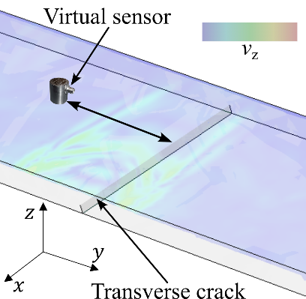

Fig. 1. Exemple of Figure.

|  |  |  |  |
| --- | --- | --- | --- |
| **AAAA** | **BBBB** | **CCCC** | **DDDD** |
| X | Y | 0,5 | 3 |
| FF | 88 | 1 | ALL |

Tab. 1. Exemple de Tableau.

**Make sure your illustrations are legible and of good quality.**

The equations are centred and identified in the text as follows (Eq. 1), preceded and followed by a

blank line in Times New Roman 10 points (provided in the ‘Normal’ style)

$\vec{F}=m\vec{a}$ (Eq. 1)

The article must include a list of bibliographical references, even brief ones, referenced as follows :

[1], [2, 3] in the text.

Please **dot not modify the header and footer zones**

References

[1] X. Yyyy, S. Zzzz, « Models for conference proceedings », in : Comptes-rendus des 20èmes Journées Nationales. sur les Composites, École des Ponts ParisTech, , pp. 75–82, 2011.

[2] N. Mmm « Ma thèse », Ph.D. thesis, Mon Institution, 2004.

[3] L. Vvvvv « Un bel Article », *Le meilleur journal* Vol. 58 n° 1, pp. 75–82, 2002.